PROJECT REPORT
Import Data using Transform Maps (Spreadsheet)
ServiceNow Data Import: loading employee data from a spreadsheet using Import Sets and Transform Maps
Detail | Information
Team ID | SWTID-2026-4458
Team Size | 5
Team Leader | Monika B
Team Members | D Keerthana  Chandhana S  Vemalaraju Poojitha  Subasri R
Date | 04 October 2026

1. INTRODUCTION

1.1 Project Overview
This project imports structured employee data from an external spreadsheet into the ServiceNow platform using Import Sets and Transform Maps. It simulates a real-world scenario where bulk employee data is received in Excel format and must be migrated into ServiceNow efficiently and accurately.
The spreadsheet data (Employee ID, Name, Email, Department and Location) is first loaded into an Import Set table, which serves as a staging area for temporary processing and validation. A Transform Map then maps the source fields to the corresponding fields in the target Employee table. Employee ID is the unique identifier: existing employees are updated and new employees are inserted as new records. After the transformation, the created records are verified to ensure data integrity.

1.2 Purpose
The purpose of the project is to:
- move employee data from a spreadsheet into ServiceNow in bulk, without manual entry;
- use an Import Set table as a staging area so data can be checked before it reaches the target table;
- map source fields to target fields accurately using a Transform Map, with Employee ID as the unique identifier; and
- help beginners understand the end-to-end import process: data loading, field mapping, transformation and result verification.

2. IDEATION PHASE

2.1 Problem Statement
Employee data is often received as spreadsheets and entered into ServiceNow by hand. Manual entry is slow, error-prone and can create duplicate or inconsistent employee records. When the same employee appears again in a new file, there is no reliable way to tell whether to create a new record or update the existing one.
Problem statement element | Description
I am | An administrator or data owner responsible for employee records
I am trying to | Import employee data from a spreadsheet into ServiceNow quickly and accurately
But | Manual entry causes mistakes, and duplicates are created for existing employees
Because | There is no automated, repeatable way to map spreadsheet columns to the Employee table and match employees by a unique ID
Which makes me feel | Frustrated by rework and unsure the data in ServiceNow is correct

2.2 Empathy Map Canvas
Empathy map for the main user, an administrator importing employee data:
Quadrant | Observations
Says | "Do I have to type all these records in?"  "Did this employee already exist in the system?"
Thinks | I want the import to finish quickly without mistakes.  I am not sure how the spreadsheet columns match the table fields.
Does | Prepares the spreadsheet, loads it and checks the records afterwards.  Sometimes fixes data by hand when the import goes wrong.
Feels | Worried about duplicate or wrong records, frustrated by rework, and relieved when the import works the first time.
Pains | Slow manual entry, duplicate records, unclear field matching, errors found late.
Gains | Fast bulk import, accurate field mapping, no duplicates, and a clear result to verify.

2.3 Brainstorming
The team considered the following ideas and chose the ones that directly address the problem:
Idea | Selected? | Reason
Load the spreadsheet into an Import Set table | Yes | Provides a staging area to check data before it reaches the target
Transform Map with field mappings to the Employee table | Yes | Moves staged data to the correct target fields
Coalesce on Employee ID | Yes | Updates existing employees and avoids duplicates
Verify results using Transform History | Yes | Confirms inserted, updated and ignored records
Transform script for data cleanup | Later | Useful, but outside current scope
Scheduled imports for recurring files | Later | Needs a Data Source and integration setup

3. REQUIREMENT ANALYSIS

3.1 Customer Journey Map
Stage | User action | User feeling | Pain point | How the solution helps
Prepare | Prepares the spreadsheet | Neutral | Data in many formats, columns unclear | Fixed columns: Employee ID, Name, Email, Department, Location
Load | Uploads the file using Load Data | Hopeful | Unsure the data loaded correctly | Import Set table shows all loaded rows
Map | Creates the Transform Map | Focused | Matching source and target fields is confusing | Field map links each column to the Employee field
Transform | Runs the transform | Anxious | Might create duplicate records | Employee ID coalesce updates existing and inserts new records
Verify | Reviews Transform History and the Employee table | Relieved | Checking records one by one is slow | History shows inserted, updated and ignored counts

3.2 Solution Requirements
Functional requirements
ID | Requirement
FR-1 | Load employee data (Employee ID, Name, Email, Department, Location) from a spreadsheet into an Import Set table.
FR-2 | Map source fields to the corresponding fields in the target Employee table using a Transform Map.
FR-3 | Use Employee ID as the coalesce field to identify existing employees.
FR-4 | Update the records of existing employees when the Employee ID matches.
FR-5 | Insert new employees as new records when the Employee ID is not found.
FR-6 | Allow the results to be verified using the Import Set rows, Transform History and the Employee table.

Non-functional requirements
ID | Requirement
NFR-1 | Accuracy: data in the target table matches the spreadsheet values.
NFR-2 | Performance: bulk records are processed in a single transform run.
NFR-3 | Maintainability: the Data Source and Transform Map are records that an administrator can edit and reuse.
NFR-4 | Data integrity: no duplicate employee records are created for the same Employee ID.

3.3 Data Flow Diagram
The user uploads the spreadsheet, and its rows are stored in the Import Set table. The Transform Map reads the staged rows, maps the fields and uses Employee ID to decide whether to update an existing record or insert a new one in the Employee table. The result is shown in Transform History.
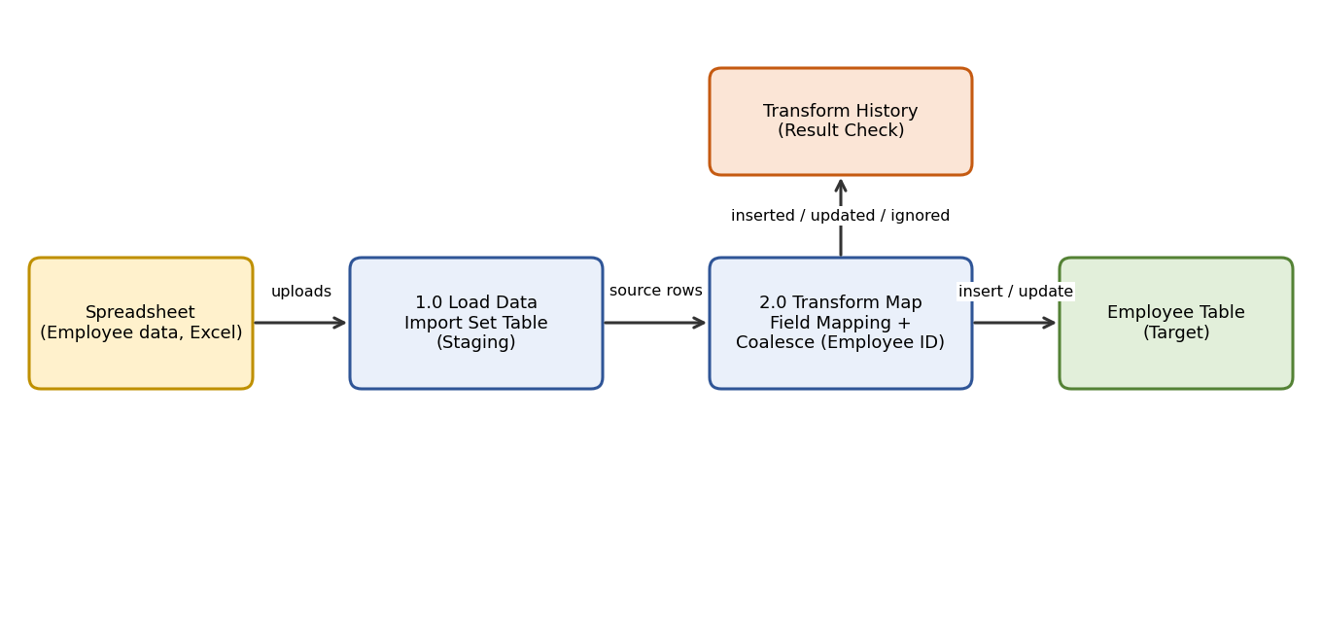
Figure 1: Data flow diagram

3.4 Technology Stack
Component | Technology
Platform | ServiceNow (Personal Developer Instance)
Table | Employee table (target); Import Set table (staging)
Data loading | Load Data / Data Source (Excel spreadsheet) and Import Set table
Mapping | Transform Map with field mappings (optional transform scripts)
Unique identifier | Coalesce on Employee ID
Deployment | Update Set
Access | Web browser

4. PROJECT DESIGN

4.1 Problem Solution Fit
Problem | Solution fit
Slow manual data entry | Bulk import from a spreadsheet using Import Sets
Duplicate employee records | Coalesce on Employee ID updates existing records
Unclear field matching | Transform Map links each source field to a target field
Errors noticed late | Import Set staging area and Transform History help verify the data

4.2 Proposed Solution
Load the employee spreadsheet into an Import Set table using Load Data. Create a Transform Map from the Import Set table to the target Employee table and map each source field (Employee ID, Name, Email, Department, Location) to its target field. Set Employee ID as the coalesce field so existing employees are updated and new employees are inserted. Run the transform and verify the results in Transform History and the target table.
Item | Details
Import Set table | Staging table that stores the loaded spreadsheet rows
Transform Map | Maps source fields to target Employee table fields
Coalesce field | Employee ID: a matching record is updated; no match inserts a new record
Run Transform | Staged rows are processed into the target table
Transform History | Shows inserted, updated and ignored records for verification
[Update the table names and field mappings above to match the final implementation.]

4.3 Solution Architecture
The spreadsheet is loaded into an Import Set table on the ServiceNow platform. The Transform Map reads the staged rows, maps the fields and writes the results to the Employee table, using Employee ID to match existing records.
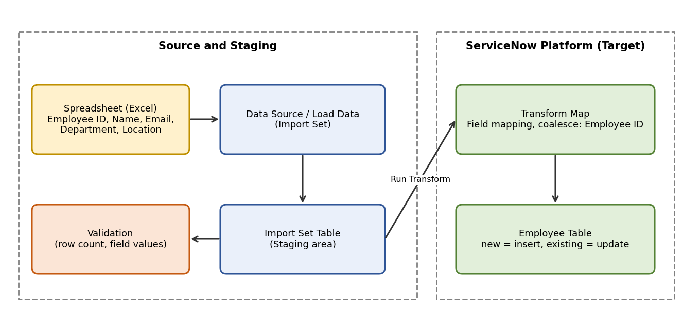
Figure 2: Solution architecture

5. PROJECT PLANNING & SCHEDULING

5.1 Project Planning
Phase | Activities | Owner | Status
Ideation | Problem statement, empathy map, brainstorming | [Assign] | [Status]
Requirement analysis | Journey map, requirements, data flow, tech stack | [Assign] | [Status]
Environment setup | Request ServiceNow PDI, prepare the employee spreadsheet | [Assign] | [Status]
Development | Load data into the Import Set table, create the Transform Map and run the transform | [Assign] | [Status]
Testing | Functional testing and UAT | [Assign] | [Status]
Documentation | Project documentation and final report | [Assign] | [Status]
[Add start and end dates and assign team members.]

6. FUNCTIONAL AND PERFORMANCE TESTING

6.1 Performance Testing
The solution was tested manually by loading the spreadsheet into the Import Set table, running the Transform Map and checking the results in Transform History and the Employee table. Test cases cover both new employees (insert) and existing employees (update).
Area | Scenarios tested | Total cases | Passed
Import Set load | Spreadsheet rows loaded; row count and field values match the source | ____ | ____
Transform Map | Field mapping to the Employee table | ____ | ____
Insert / update | New employees inserted; existing employees updated using Employee ID | ____ | ____
Total |  | ____ | ____
[Enter the pass counts and screenshots from the UAT document.]

7. RESULTS

7.1 Output Screenshots
[Insert screenshot: Import Set table with the loaded spreadsheet rows]
[Insert screenshot: Transform Map with field mappings]
[Insert screenshot: Employee ID set as the coalesce field]
[Insert screenshot: Transform History after running the transform]
[Insert screenshot: Employee records in the target table]

8. ADVANTAGES & DISADVANTAGES
Advantages
- Bulk employee data is imported quickly instead of being entered by hand.
- Fewer duplicate and inconsistent records because Employee ID is used to match employees.
- The staging area allows data to be checked before it reaches the target table.
- The Data Source and Transform Map can be reused and edited by an administrator.
Disadvantages
- Poor-quality spreadsheet data (missing or duplicate Employee IDs) leads to skipped or wrong updates, so data must be cleaned first.
- Many field mappings or transform scripts can make the Transform Map harder to maintain.
- A mistaken coalesce setting can overwrite existing records, so the Transform Map should be tested before bulk imports.

9. CONCLUSION
The project shows how Import Sets and Transform Maps can move bulk employee data from a spreadsheet into ServiceNow accurately and efficiently. By staging the data first and using Employee ID as the unique identifier, the process inserts new employees and updates existing ones without duplicates, giving beginners a clear end-to-end view of loading, mapping, transforming and verifying data.

10. FUTURE SCOPE
- Add transform scripts or Business Rules to validate data (for example, email format) during import.
- Use Scheduled Imports to load employee files automatically on a recurring basis.
- Add error reporting and notifications for ignored or failed rows.
- Package the changes as a scoped application for easier deployment.

11. APPENDIX
Source Code
Example onBefore Transform Map script (replace with the team's final script):
(function runTransformScript(source, map, log, target) {
// Skip rows that have no Employee ID
if (source.u_employee_id == '') {
ignore = true;
log.info('Row skipped: Employee ID is missing');
}
})(source, map, log, target);

Dataset Link: The employee spreadsheet (Excel) with Employee ID, Name, Email, Department and Location. [Add link or file name]
GitHub & Project Demo Link: [Add link]

